Stock Allotment - Department/Directorate

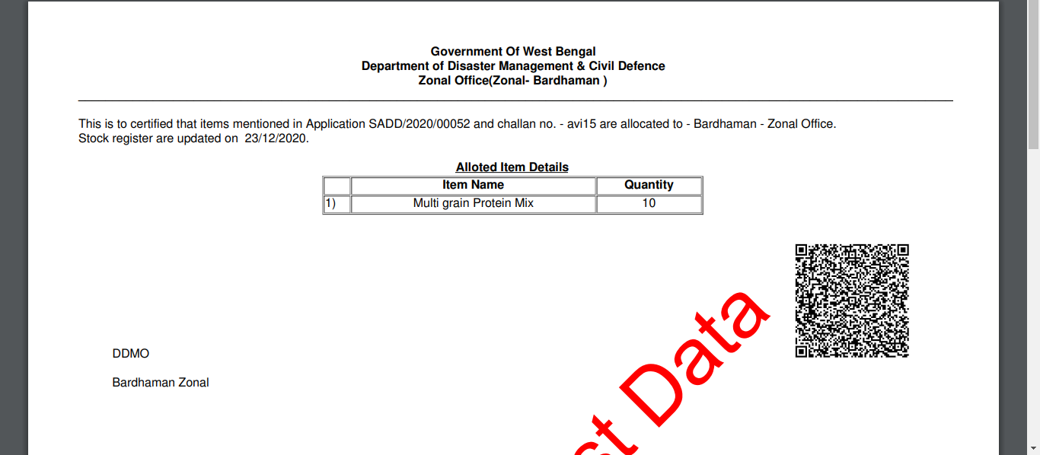

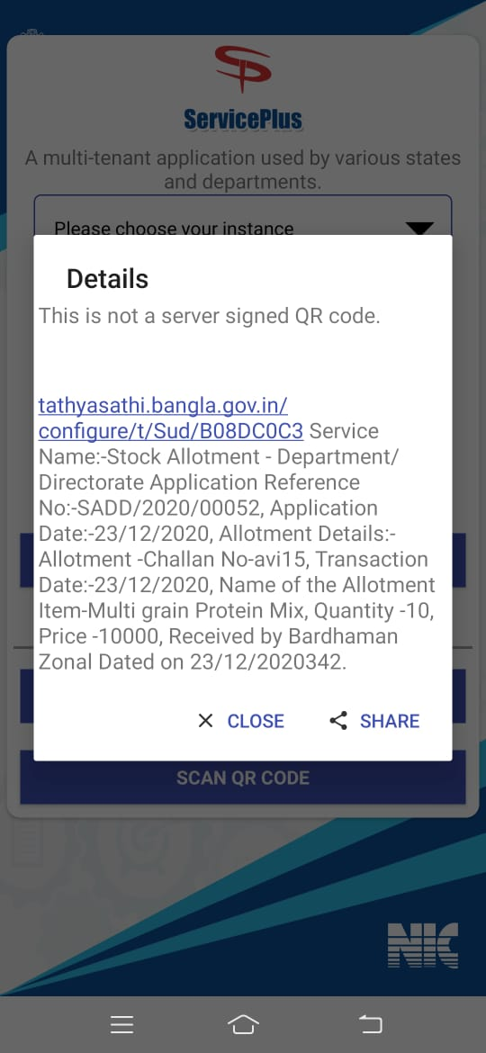

#### Application Form - Stock Updation / Rejection - Department/Directorate

#### Updation for Direct Supply

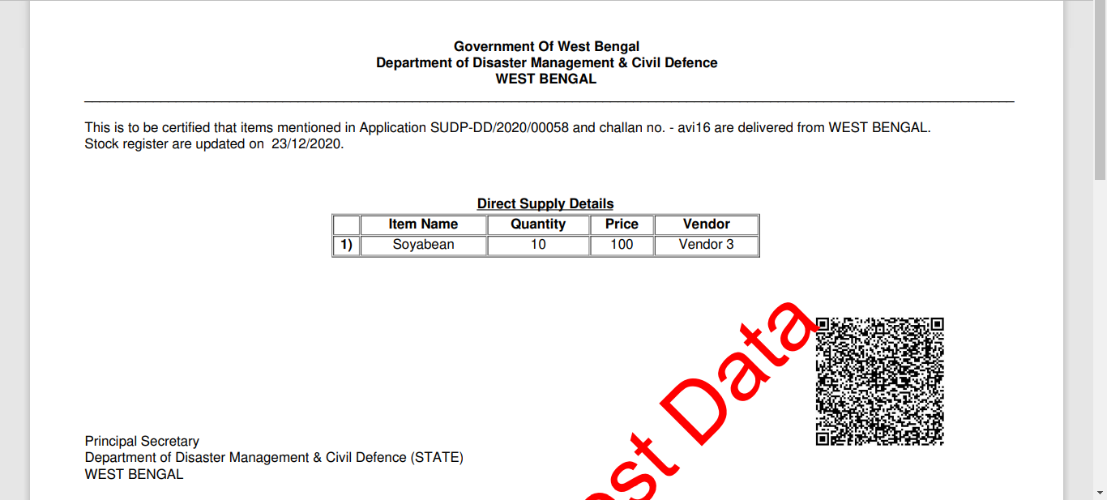

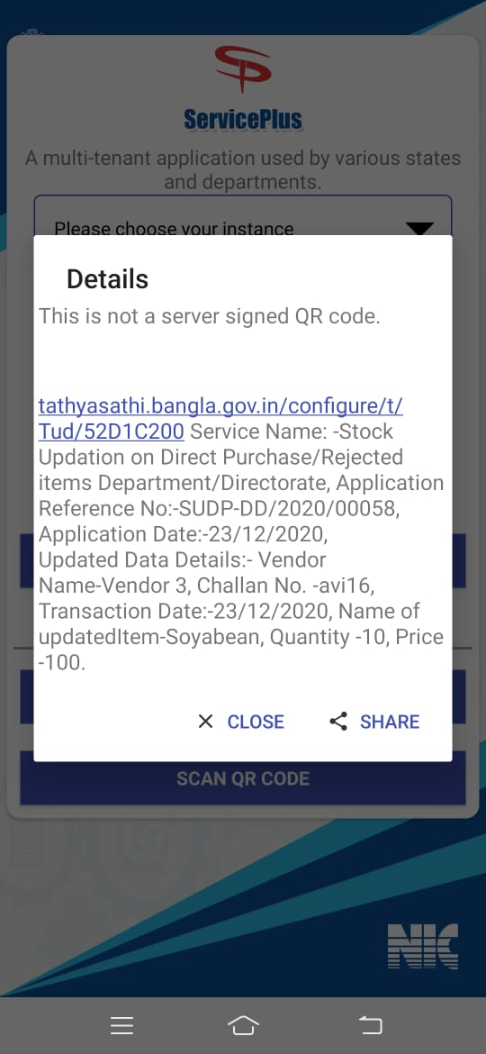

#### Application Form - Stock Updation / Rejection - Department/Directorate

#### Rejection for Stock Item

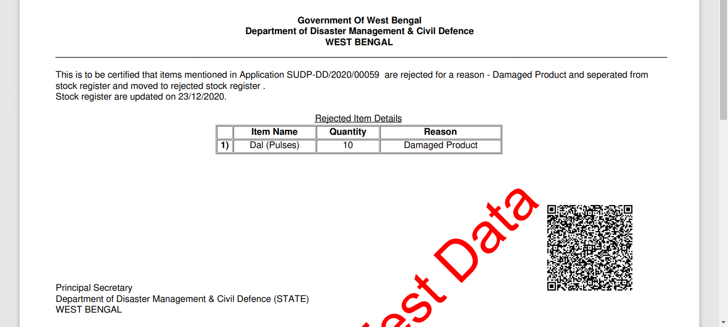

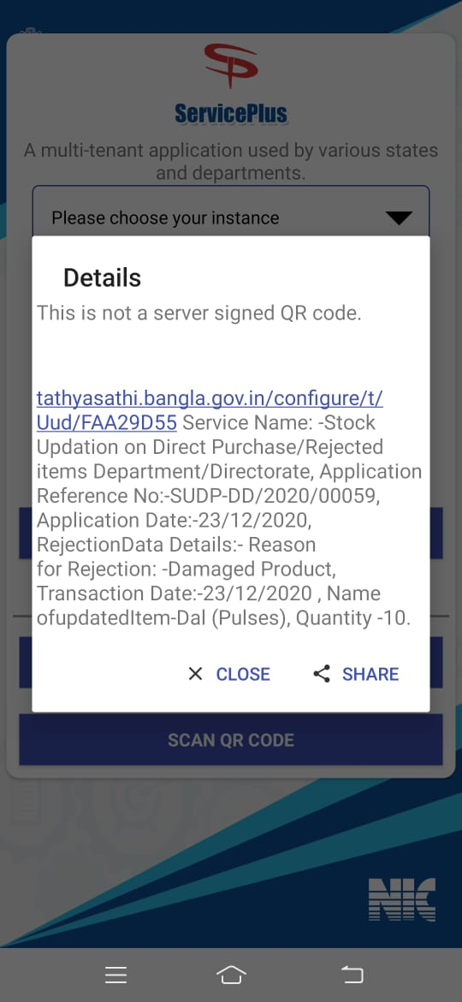

#### Application Form - Stock Requisition - Zonal

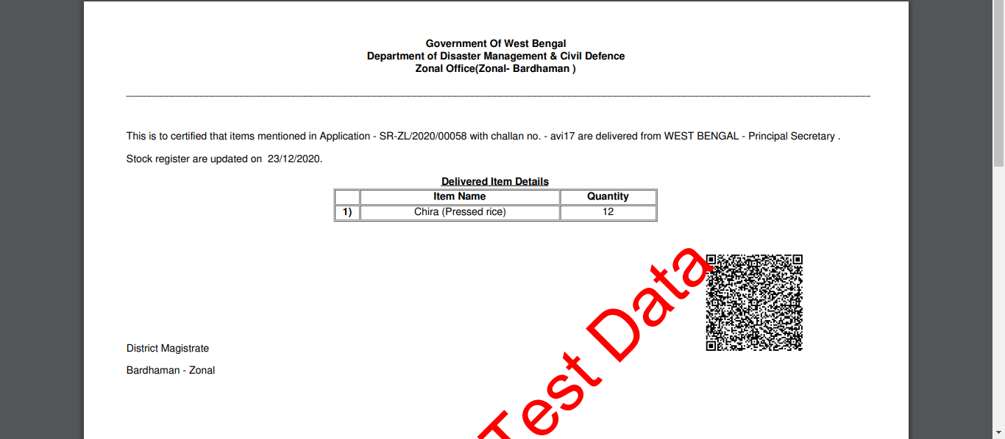

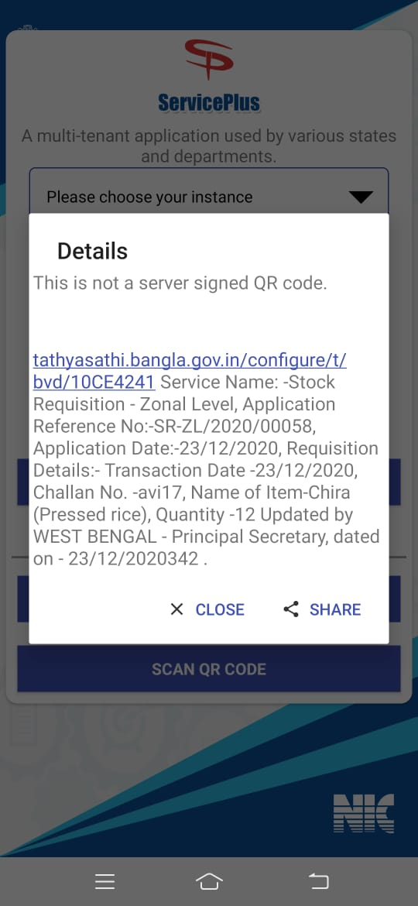

#### Application Form - Stock Updation on Direct Supply / Rejected Item – Zonal

#### Updation for Direct Supply

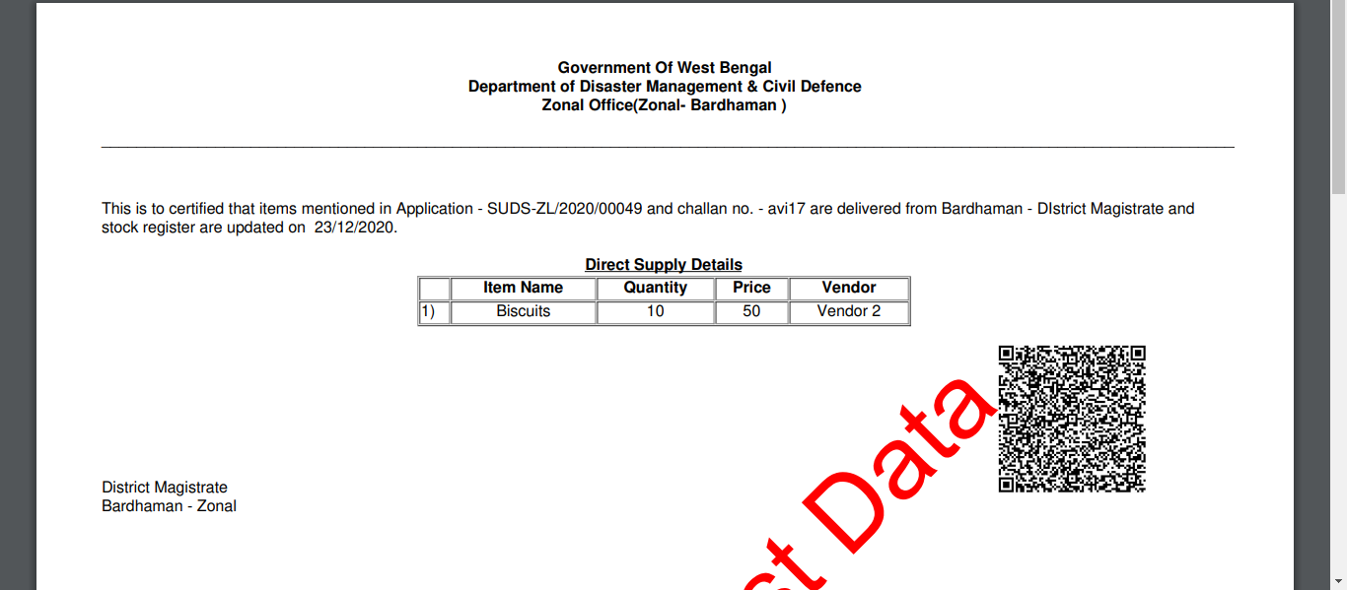

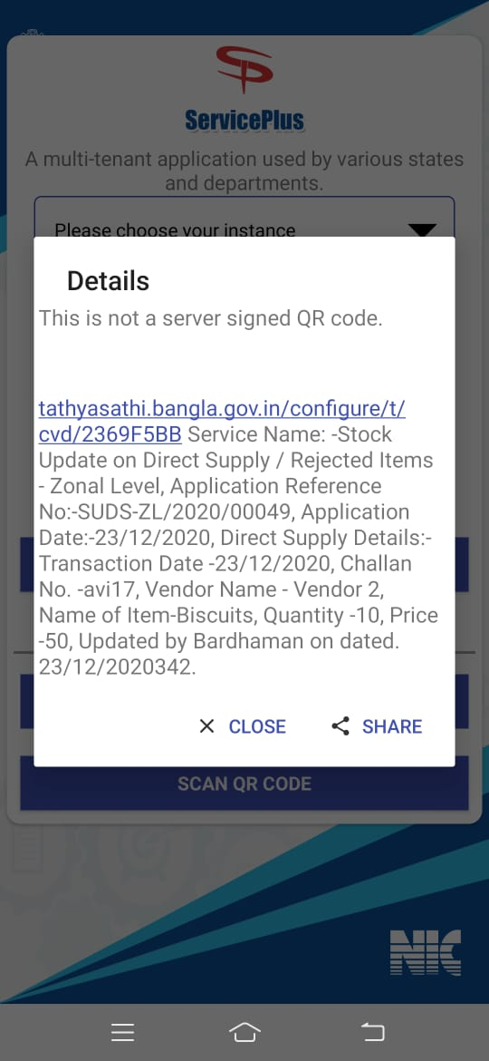

Application Form - Stock Updation on Direct Supply / Rejected Item – Zonal

 Rejection for Stock Item

